
MULTIMEDIA UNIVERSITY OF KENYA
FACULTY OF COMPUTING & INFORMATION TECHNOLOGY

FAKE NEWS PROJECT
BY
NAME: OKOTO COLLINCE OMONDI
REG. No: CIT-223-039/2021

SUPERVISOR: Mr. Mokodir

JANUARY 2025
________________________________________________________________________
Submitted in partial fulfillment of the requirements of Fourth Year Bachelor of Science in Computer Science.
DECLARATION
I hereby declare that this Project has been composed solely by myself and has not been submitted in any previous application for a degree, except where it is stated otherwise by the references.

Student: OKOTO COLLINCE OMONDI
Registration Number: CIT-223-039/2021
Signature: ............................................... Date: .....................................................

This project has been submitted as a partial fulfillment of requirements for the Bachelor of Science in Computer Science of the Multimedia University of Kenya with my approval as the University supervisor.
Supervisor: …………………………….
Signature: .....................................................
Date: ..................................................

DEDICATION
I dedicate this project to my parents for providing me with the resources and my wonderful supervisor for giving me the required guidance for my project

ABSTRACT
The proliferation of fake news in online platforms presents a significant challenge, impacting not only individuals and businesses but also society at large. The project aimed to address this issue by developing a machine learning model capable of identifying fake news articles with a high degree of accuracy. By leveraging Random Forest algorithm, the model empowered users to make informed decisions and combat the spread of misinformation.
The project began with an exploration of the prevalence and impact of fake news, highlighting its potential to manipulate public opinion and disrupt democratic processes. Through a comprehensive review of existing systems and methodologies, including text augmentation and stance detection, the limitations of current approaches were identified thus paving the way for the proposed solution.
The project proceeded with the design and implementation of the Random Forest algorithm, starting from data preprocessing to model evaluation. Key steps included text cleaning, feature extraction using TF-IDF vectorization, model training, and hyper parameter tuning to optimize performance.
The effectiveness of the model was then demonstrated through testing on a dataset that had labeled news articles. Evaluation metrics such as accuracy, precision, recall, and confusion matrices were used to evaluate the model.
Finally, the project concluded with the deployment of the model, enabling users to interact with it through a user-friendly interface.

ACKNOWLEDGEMENT
The successful completion of this project owes much to the cooperation and support of numerous individuals whose contributions have far exceeded the scope of my class studies.
First and foremost, I am profoundly grateful to my family members, particularly my parents, for their unwavering support, both morally and financially. Their encouragement and belief in my abilities have been the cornerstone of my development and learning journey.
I extend my sincere appreciation to MMU for their steadfast support and for granting me the opportunity to be part of their esteemed organization. The invaluable support and guidance I received from them have been instrumental in shaping my understanding and proficiency in tackling the challenges of this project.
I would be remiss not to acknowledge the exceptional mentorship provided by my supervisor Mr. Patrick Mokodir. Despite his demanding responsibilities, he graciously agreed to oversee my supervised guidance and offered unwavering assistance whenever I sought his guidance. His expertise and encouragement have been indispensable in navigating the complexities of this project.

Contents
DEDICATION ii
ABSTRACT iii
ACKNOWLEDGEMENT iv
List of figures vii
CHAPTER 1: INTRODUCTION 1
1.1 Background of the study 1
1.2 Problem statement 1
1.3 Aim of the study 2
1.3.1 Objectives of the study 2
1.4 Significance of the study 3
1.5 Scope of the system 3
1.6 Assumptions 3
1.7 Limitations 4
CHAPTER 2: LITERATURE REVIEW 5
2.1 Introduction 5
2.2 Related systems 5
2.3 Limitations of these systems 6
2.4 How the proposed solution will handle these weaknesses. 6
CHAPTER 3: DESIGN CONCEPTS 8
3.1 System Architecture 8
3.2 User Interface Design 8
3.2.1 Simplicity and Minimalism 9
3.2.2 Clarity and Feedback 9
3.2.3 Visual Language 10
3.3 Model Selection Justification 10
3.4 Tools and Implementation 10
3.5 Validation Strategy 11
CHAPTER 4: METHODOLOGY 12
4.1 Random Forest Pseudocode 12
4.2 Description Of The Dataset 13
4.2.1 Breakdown of the dataset 13
4.3 Analysis Of Random Forest Algorithm 14
4.4 Project Resources Summary 14
4.5 Project schedule 15
4.6 Project budget 17
CHAPTER 5: DESIGN AND IMPLEMENTATION OF RANDOM FOREST ALGORITHM 18
5.1 Input 18
5.3 Splitting the Dataset into training and testing 19
5.4 Pipelining 19
5.5 Evaluation 20
5.6 Testing the Model 20
CHAPTER 6: RESULTS AND CONCLUSION 22
6.1 Results based on objectives 22
6.1.1 Designing of textual classification model capable of classifying textual data as Real or Fake 22
6.1.2 Enabling multilingual fake news detection 23
6.1.3 Creating a simple and user-friendly interface 25
6.1.4 Discussing the results 26
6.2 Conclusion 28
CHAPTER 7: REFERENCES 30

List of figures
Figure 1 System Architecture 8
Figure 2 Homepage design on Figma 9
Figure 3 Results Page 10
Figure 4 20
Figure 5-Results 21
Figure 6 22
Figure 7 23
Figure 8 24
Figure 9 24
Figure 10-Home_Page 25
Figure 11-Results_Page 26

CHAPTER 1: INTRODUCTION

1.1 Background of the study
The internet according to the dictionary is a computer network providing a variety of information and communication facilities, consisting of interconnected networks using standardized communication protocols. The internet has enabled fast sharing of information since its inception compared to the traditional methods of communication. But with every good invention comes some challenges to some users which is of benefit to others a good example being hackers and it can also be your competitor in different fields such as in politics where the information transmitted can be manipulated in one way or another to break trust and also target one's reputation. Moreover, the distorted information can be used to make money through advertising revenue. The information that has been manipulated by the third party is termed fake since it lacks credibility.
Hence the need for technology to identify and curb the manipulation of information before getting to the target audience. Fake news tends to spread rapidly on social media and the internet, reaching millions within hours. Fake news has social and political damage and its widespread has led to a lot of critical concern. Studies show that nearly 70% of adults encounter fake news online. And according to thegurdian.com, 85% of people worry about the impact of online disinformation and 87% believe it has already harmed their country's politics, according to a global survey. News exists in different forms such as textual-based, video, and image representation. It is important to note that no form of news is immune to manipulation hence the need for a good solution to curb it all forms of news with a high degree of accuracy.

1.2 Problem statement
The reliability of information poses a persistent challenge impacting both businesses and society whether in the traditional print or digital form with the invention of the internet and ever-evolving technology. In social networks, the rapid and amplified dissemination of information has the potential of quickly and extensively impacting millions of users, leading to real-world consequences simply because distorted and inaccurate information gains significant influence within seconds if not minutes.
For example, the survey by pollster Ipsos of 8,000 people in countries including
Austria, Croatia, the US, Algeria, Mexico, Ghana, and India, found that 56% of internet users mainly got their news from social media, far more than 445 from TV, and 29% from media sites.
Across all 16 countries, 68% of the respondents mentioned that social media was where fake news was most widespread, ahead of messaging apps which covered only 38%.
False information and hate speech online can not only cause social cohesion but it can also tamper with peace and stability of a nation according to thegurdian.com thus the need to build a user-friendly tool that empowers individuals to evaluate the credibility of news at its early stages, its sources and content, based on various indicators which in turn promote media literacy and responsible information consumption.

1.3 Aim of the study
This study is aimed at developing a machine learning model that achieves a specific level of accuracy (e.g. 80% and above) in identifying fake news articles on social media and the internet thus empowering informed decision-making by flagging potential misinformation and eventually user will be more critical consumers of information and less likely to share or believe fake news.

1.3.1 Objectives of the study
The study aims to achieve the following objectives:
- To design textual classification model-Build and train machine learning model capable of classifying textual news as real or fake.
- To enable multilingual fake news detection-Ensure multilingual support to detect and classify fake news in both English and Kiswahili.
- To enhance detection accuracy through continuous evaluation and refinement.
- Create a simple and user-friendly interface-Design and implement a user-friendly web interface where users can verify authenticity of news.

1.4 Significance of the study
This model will be of great significance in various domains as listed below:
- Countering misinformation and disinformation
Minimized exposure to harmful content by identifying and filtering fake news. The model will shield users from misleading information.
- Enhanced decision making
Accurate information is pivotal for making informed decisions. The model will provide accurate information to aid in making decisions thus enhancing the decisions made by individuals.
- Combatting manipulation and propaganda
Fake news can manipulate public opinion and disrupt democratic processes. The model will counter and identify such content thus upholding democratic values and safeguarding the integrity of the public.
- Improved credibility of online platforms
The model will address the issue of fake news thus bolstering trust between users and social media platforms.
- Empowered users
This model will act as a tool for the identification of fake news thus empowering users to critically assess information online.

1.5 Scope of the system
- The model will be capable of analyzing textual contents and determining whether the news is fake or real’
- The model will work across various online environments
- The model will be easy to use
- The model will be in a position to handle large amounts of data.

1.6 Assumptions
- Assume that the tactics and strategies employed by creators of fake news remain relatively stable over time thus allowing the model to not only learn but also to adapt effectively.
- Assume that there is a clear and distinct universally agreed difference between real and fake news.
- Assume that the training data used to develop the model fully represents the wide range of fake news.
- Assume that the model does not introduce any biases
- Assume that users consistently react to fake news identically without accounting for variations in individual responses and behaviors.
- Assume that there is an objective and undisputed “ground truth” for every piece of information, neglecting the complexities.
- Assume that the model will perform equally well across diverse cultures.
- Assume that the emerging tactics used by fake news creators can be predicted and incorporated into the model proactively without facing unforeseen challenges.

1.7 Limitations
- Biasness
Like any AI model, this model can be biased on training data.
- Challenges with multimedia content
Detecting fake news in images, videos and other non-text formats poses additional challenges.
- Limited training data
The effectiveness of this model heavily depends on the quality and diversity of training data. Thus, limited training data will make the model struggle in tokenization, data extraction, grouping, and generalizing the news.
- Time
Time is a very important factor when developing a model with a high level of accuracy, thus the limited time windows posed a serious challenge to me.

CHAPTER 2: LITERATURE REVIEW

2.1 Introduction
The widespread adoption of digital technology has led to an increase in the prevalence of information pollution, primarily driven by the proliferation of fake news. Therefore, fake news is a major issue in the current regime and can lead to tultomous situation and affect major events as seen in 2016 United States general elections where spread of misinformation through Twitter and Facebook affected the outcome of the general election. Moreover, the Islamic State terrorist organization (ISIS) used extensive Twitter campaigns to spread propaganda, encourage radicalization and recruit foreign soldiers for its war in Iraq and Syria (Klausen 2015).

2.2 Related systems
Several systems have been developed to address the challenge of detecting fake news and misinformation. One such approach involves the use of text augmentation techniques to enhance stance detection and improve fake news identification. Text augmentation methods generate variations of existing text data to increase the diversity of training datasets, and by doing so it increases the accuracy and robustness of machine learning models in classifying textual fake news.
Another widely used system is the Fake News Challenge (FNC) stance detection model. This system employs stance detection techniques to analyze how different pieces of text relate to one another, particularly in terms of agreement, disagreement, or neutrality. By determining the stance of a given statement toward a reference article, Fit can can assess the likelihood of misinformation, making them valuable tools in combating the spread of false narratives.
These systems, among others, continue to evolve as researchers refine their methodologies to improve the detection and mitigation of fake news in an increasingly digital and information-driven world.

2.3 Limitations of these systems
1. Lack of Ground Truth
Establishing a clear ground truth for the stance method is challenging, as people's perspectives on what constitutes a particular stance may vary, making it difficult to create a consistent training dataset.
2. Stance detection may struggle with distinguishing between genuine differences in opinion and manipulative rhetoric, potentially mislabeling legitimate expressions as fake news.
3. Semantic Integrity
Augmented text may not preserve the original semantic meaning, potentially leading to the generation of incorrect sentences. This can impact the model's understanding and generalization.
4. Increased Training Time
Augmenting the dataset can significantly increase training time, especially for large models, as the augmented data expands the overall size of the training set.

2.4 How the proposed solution will handle these weaknesses.
1. Lack of Ground Truth Random
Forest's ensemble approach can mitigate the impact of varying perspectives by aggregating decisions from multiple trees, offering a more robust stance classification. On the other hand, hyper parameter tuning, specifically adjusting tree depth or the number of trees, can help balance model complexity and performance, enhancing its adaptability to diverse perspectives.
2. Stance Detection Challenges
Hyper parameter tuning can optimize Random Forest's sensitivity to nuanced features, aiding in distinguishing genuine differences in opinion from manipulative rhetoric. Fine-tuning parameters such as tree depth can enhance the model's ability to discern subtle distinctions, reducing the risk of mislabeling.
3. Semantic Integrity Concerns
Random Forest is resilient to over-fitting and coupled with careful hyper parameter tuning, can help to a greater degree maintain semantic integrity, if need be.
4. Increased Training Time
Random forest has reduced training time thus efficiently curbing the increased training time.

CHAPTER 3: DESIGN CONCEPTS

3.1 System Architecture
The Fake News Detection system integrates a machine learning backend (Random Forest model) with a user-friendly frontend. The workflow is as follows:
- User Input: Text is submitted via a web interface.
- Pre-processing: TF-IDF vectorization and text cleaning (stopword removal, lemmatization).
- Model Inference: Classification is performed using the trained Random Forest model.
- Output: A prediction ("Real" or "Fake") is displayed along with explanatory feedback.
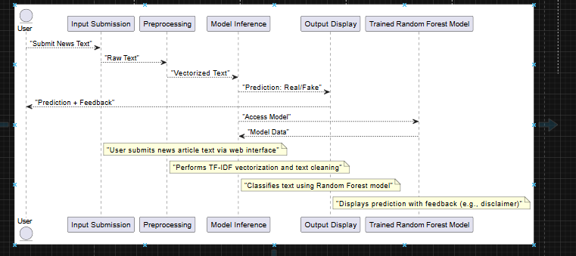
Figure 1 System Architecture

3.2 User Interface Design
Guided by principles of simplicity, clarity, and accessibility, the UI was prototyped in Figma and implemented using HTML, Tailwind CSS, and JavaScript.

3.2.1 Simplicity and Minimalism
- Homepage: A clean interface featuring:
  - A text area for news input.
  - A language model dropdown (English/Kiswahili).
  - A prominent "Check News" button.
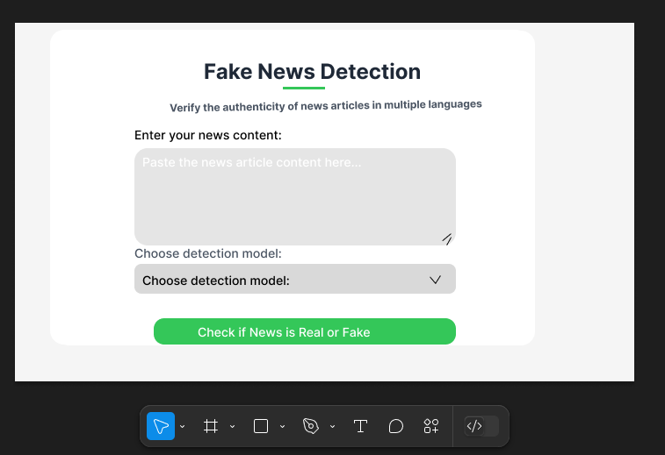
Figure 2 Homepage design on Figma

3.2.2 Clarity and Feedback
- Placeholder Text: Provides guidance to users (e.g., "Paste news article here...").
- Results Page: Displays the prediction (e.g., "REAL") along with:
  - Color Coding: Green (#34c759) for "Real" and red (#ff0000) for "Fake."
  - Disclaimer: Encourages users to cross-verify information (see Figure 3).
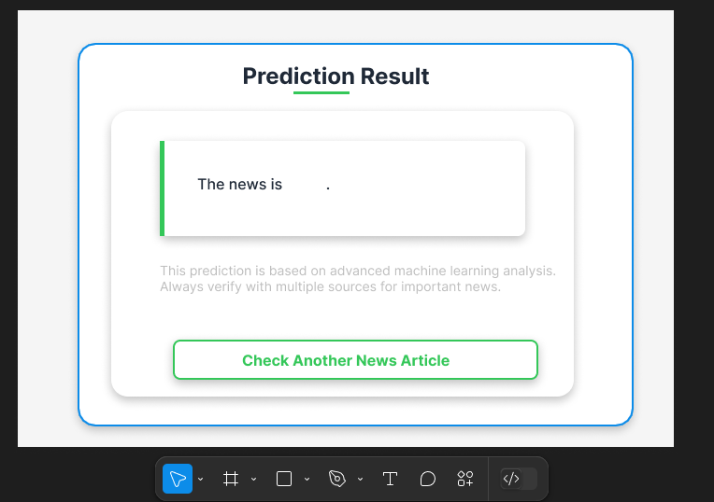
Figure 3 Results Page

3.2.3 Visual Language
- Rounded corners, drop shadows, and consistent typography enhance usability.

3.3 Model Selection Justification
- Random Forest: Selected due to:
  - High accuracy (~99% for English, ~95% for Swahili).
  - Robustness against overfitting (compared to single decision trees).
  - Efficient processing of TF-IDF vectorized text.
- Multilingual Support: Separate models were trained on English and Swahili datasets.

3.4 Tools and Implementation
- Frontend:
  - Figma: Used for high-fidelity prototyping.
  - Tailwind CSS: Enables responsive and scalable styling.
  - JavaScript: Handles dynamic interactions (e.g., displaying results).
- Backend: Python (Scikit-learn, NLTK) is used for model training and inference.

3.5 Validation Strategy
- User Testing: Iterative feedback was gathered to refine UI clarity and model performance.

CHAPTER 4: METHODOLOGY
There exists a number of algorithms namely logistic regression, SVM (Support vector Machine) , KNN, Random forest(RF) , each with a specific purpose while others can be used in more than one task.
For example, Random Forest algorithms can be used to build a model for both classification and regression problems, not only for high-volume data but also for high accurate results.
The Random Forest Algorithm is a skilled machine learning model that is widely used for both classification and regression tasks. It delivers flexibility and ease of use by combining multiple decision trees, moreover it yields good results without extensive hyper-parameter tuning. In the realm of discerning fake and real news, this algorithm has proven successful. Research incorporating Random Forest and Natural Language Processing (NLP) has led to models adept at classifying articles based on their content, demonstrating high accuracy in distinguishing between trustworthy and untrustworthy information. Therefore, a number of pieces of evidence suggests the effectiveness of the Random Forest Algorithm in the classification of fake and real news.

4.1 Random Forest Pseudocode
Precondition: A training set S := (x1, y1), . . . ,(xn, yn), features F, and number
of trees in forest B.
1 function RandomForest(S , F)
2 H ← ∅
3 for i ∈ 1, . . . ,B do
4 S(i)←A bootstrap sample from S
5 hi←RandomizedTreeLearn(S^{(i)}, F)
6 H← H ∪ {hi}
7 end for
8 return H
9 end function
10 function RandomizedTreeLearn(S , F)
11 At each node:
12 f ← very small subset of F
13 Split on best feature in f
14 return The learned tree
15 end function

4.2 Description Of The Dataset
The dataset provided is a collection of news articles labeled as either 0 for "FAKE" or 1 for "REAL", and it indicates whether the article is considered fake news or not.

4.2.1 Breakdown of the dataset

4.2.1.1 English Dataset
- Number of Instances is 44,880
- it has the following features:
- text: The content of the news article.
- Class: Indicates whether the news article is labeled as 0 for "FAKE" or 1 for "REAL".
The datasets are aimed at addressing the issue of fake news , which has become a significant problem in modern society, particularly in the online environment.

4.2.1.2 Swahili Dataset
- Number of Instances is 6,548
- it has the following features:
- translated_text: The content of the news article.
- Class: Indicates whether the news article is labeled as 0 for "FAKE" or 1 for "REAL".
The source of the dataset is Kaggle, which is a platform for sharing datasets that are used in machine learning tasks. This dataset is very valuable for training machine learning models to automatically detect and classify fake news articles.
For the Swahili dataset I will translate the English dataset in portions using Helsinki pretrained model on google colab which provide access to GPU hence faster and efficient translation . The Helsinki-NLP model, also known as Opus-MT, is an open-source machine translation model developed by the University of Helsinki. It’s built using the Marian NMT framework and provides pretrained models for hundreds of language pairs.

4.3 Analysis Of Random Forest Algorithm
The random forest algorithm uses the bagging technique for building an ensemble of decision trees. Bagging is known to reduce the variance of the algorithm.
However, the natural question to ask is why the ensemble works better when we choose features from random subsets rather than learn the tree using the traditional algorithm. We recall, that ensembles are more effective when the individual models that comprise them are uncorrelated. In traditional bagging with decision trees, the constituent decision trees may end up being much correlated because the same features will tend to be used repeatedly to split the bootstrap samples. By restricting each split test to a small, random sample of features, we can decrease the correlation between trees in the ensemble.
Furthermore, by restricting the features that we consider at each node, we can learn each tree much faster, and therefore, can learn more decision trees in a given amount of time. Thus, not only can we build many more trees using the randomized tree learning algorithm, but these trees will also be less correlated. For these reasons, random forests tend to have excellent performance

4.4 Project Resources Summary
This project utilizes the following resources to develop, train, and deploy a model for detecting powdery mildew in mangoes.
Hardware Resources:
- A laptop with an Intel Core as from core i5 processor, 4GB RAM and above and 256GB SSD storage
- Cloud platforms like Google Colab for GPU integration and dataset management.
Software Resources:
- Programming Tools specifically Python like Jupyter Notebook for coding .
- Dataset Platforms like Kaggle for accessing high-quality image datasets.

4.5 Project schedule
Project Schedule for Fake News Detection Project (January – April 2025)
To ensure the successful completion of the project within the given timeframe, the schedule is divided into key phases: Research & Planning, Data Collection & Preprocessing, Model Development, Evaluation & Optimization, and Documentation & Final Submission.
January 2025 – Research & Planning (Week 1-4)
- Define project scope, objectives, and significance
- Conduct an in-depth literature review on fake news detection
- Identify relevant datasets (Kaggle, online sources)
- Select machine learning model (Random Forest) and key libraries (NLTK, TF-IDF, Scikit-learn)
- Draft the introduction and literature review sections of the report
February 2025 – Data Collection & Preprocessing (Week 5-8)
- Collect and clean dataset (remove duplicates, handle missing values)
- Perform text preprocessing (tokenization, stopword removal, stemming/lemmatization)
- Extract features using TF-IDF vectorization
- Split dataset into training and testing sets
Deliverables:
- Cleaned dataset ready for model training
- Initial report sections (data description, preprocessing steps)
March 2025 – Model Development & Evaluation (Week 9-12)
- Train the Random Forest model .
- Evaluate model performance using accuracy, precision, recall, and F1-score
- Compare results with other classifiers (e.g., Logistic Regression, SVM)
- Optimize model by tuning hyperparameters
- Begin implementation of a simple user interface (if applicable)
Deliverables:
- Trained and optimized model with evaluation results
- Model performance comparison report
April 2025 – Deployment & Final Documentation (Week 13-16)
- Finalize the model and ensure it is ready for deployment
- Develop a simple interface (e.g., web-based or command-line tool)
- Conduct final testing and validation of the model
- Complete final report (methodology, results, discussion, conclusion)
- Prepare and submit final project presentation
Deliverables:
- Working fake news detection model
- Complete project report and presentation slides
Final Submission Deadline: End of April 2025
This schedule ensures timely progress while allowing flexibility for improvements. Adjustments can be made as needed.

4.6 Project budget
Google colab | Free (Colab Pro optional at ~2,000/month) | 0-2000
Jupyter Notebook | Free | 0
Kaggle Dataset Access | Free | 0
Miscellaneous | Internet and power costs (for development) | 2,000 - 5,000
Laptop | Core i5, 4GB RAM, 256GB SSD (Used/Refurbished) | 20,000-50,000
Total |  | 22,000-57,000

CHAPTER 5: DESIGN AND IMPLEMENTATION OF RANDOM FOREST ALGORITHM

5.1 Input
This is the first step and it will basically involve loading a dataset that is labeled as either fake(0) or real(1).
5.2 Preprocessing
Preprocessing is the cleaning of data and making it favorable for training and testing.
We preprocess the text field for English dataset and translated_text field for Swahili dataset. In the first model I converted the dataset to lowercase and used the functions listed below in cleaning.
For the other models in made use of TFIDF vectorizer to perform preprocessing thereby r
The removePunctuation function-Used to remove the punctuations.
The removeStopwords function
Used to remove stopwords.Stopwords are common words (like the, is, in, and, to) that are often filtered out in natural language processing (NLP) tasks because they don’t carry significant meaning in text analysis.
For example, in a sentence like:
"The cat is sitting on the mat."
Words like "the," "is," and "on" might be considered stopwords because they appear frequently and don’t contribute much to the sentence’s core meaning.
Reason for removal of stopword?
Reduces dataset size – Less storage and processing time.
Improves efficiency – Eliminates unnecessary words, making models focus on meaningful content.
Enhances accuracy – Helps NLP models focus on important words rather than noise.

Examples of Stopwords in Different Languages
English: a, an, the, and, but, or, is, are, he, she, it, we, they.
Spanish: el, la, los, las, y, o, pero, que, este, esa...
Swahili:mimi, wewe, yeye, sisi, wao, ya, kwa, na, katika, lakini.
remove_Specialcharacters
Used to remove special charaters like periods(.),comma(,) for punctuation and symbols like copyright(©) etc.
Lemmatize_text
Used to perfom lemmatization.Lemmatization is the process of reducing different forms of a word to a single form. It often uses a vocabulary or dictionary to map words to their corresponding lemmas.
Example:
"running," "runs," and "ran" would all be reduced to the lemma "run".
"better" would be reduced to the lemma "good".

5.3 Splitting the Dataset into training and testing
After text preprocessing the dataset is divided into training and testing set using train_test_split method.
- It is typically recommended to use around 70%-85% of the dataset for training, and the remaining 15%-30% for testing.

5.4 Pipelining
A pipeline was used to automate two processes:
I) conversion of dataset to numerical form using the tfidf(term frequency inverse document frequency) vectorizer .It also does text preprocessing.
II) Training of dataset using Random Forest Algorithm from ensemble method.
After creating the pipeline, the training dataset is fit into the pipeline, this is followed by making predictions using the dataset

5.5 Evaluation
This step involves checking the performance of the Random Forest model using appropriate metrics e.g., accuracy score, precision, recall etc.

5.6 Testing the Model
The final step was to test my model. Testing was done on the notebook editor first.
Later it was done on a simple graphical user interface where one could paste the news and results displayed in results. As shown below:
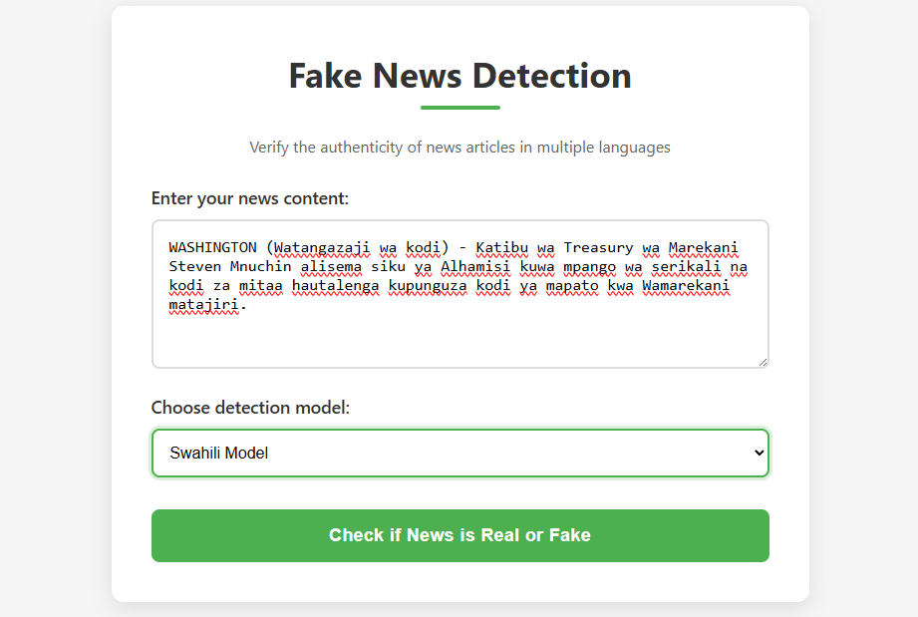
Figure 4
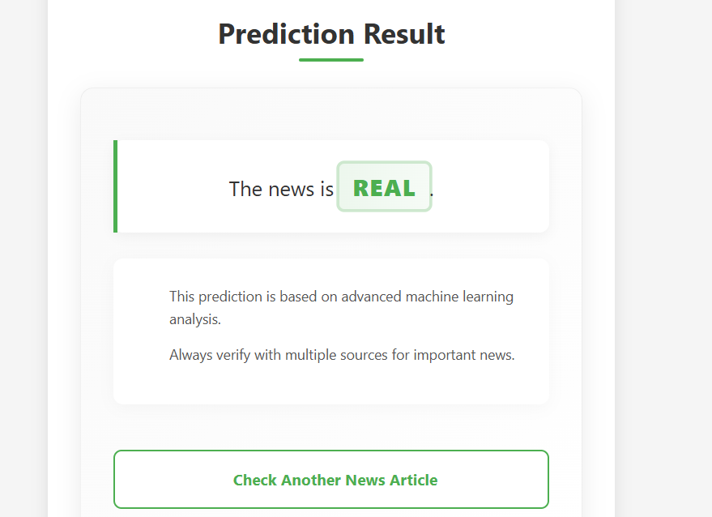
Figure 5-Results

CHAPTER 6: RESULTS AND CONCLUSION

6.1 Results based on objectives

6.1.1 Designing of textual classification model capable of classifying textual data as Real or Fake
I Built and trained machine learning model capable of classifying textual news as real or fake.
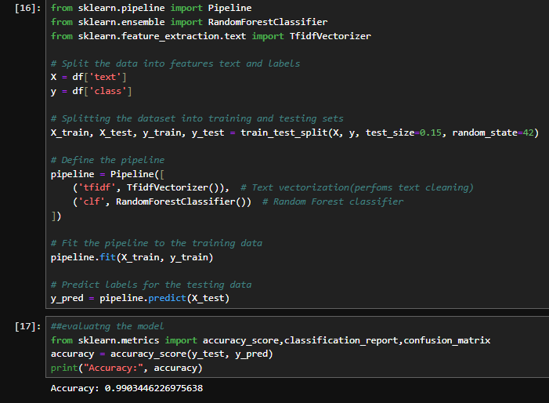
Figure 6

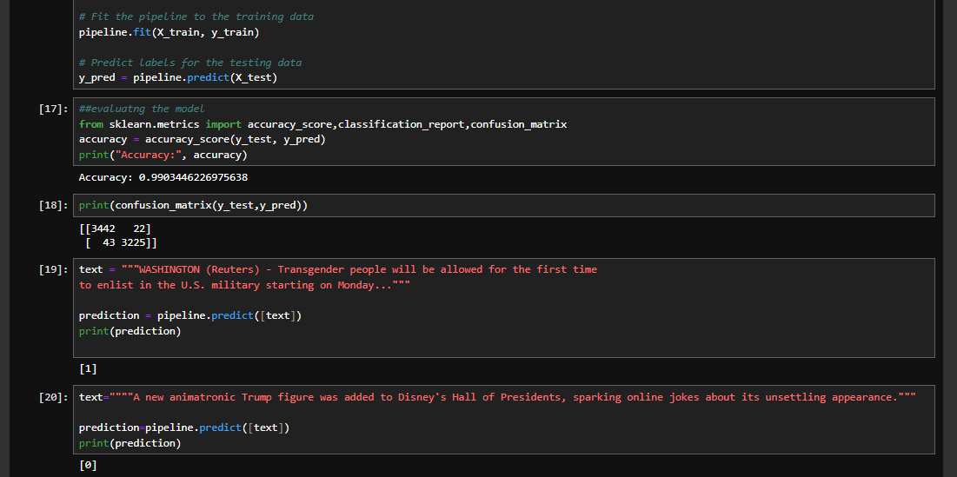
Figure 7

6.1.2 Enabling multilingual fake news detection
I ensured there is multilingual support to detect and classify fake news in both English and Kiswahili by training my model(random forest) on English dataset for English news detection. Likewise I trained my model on Kiswahili dataset. More languages will be added as time goes by.
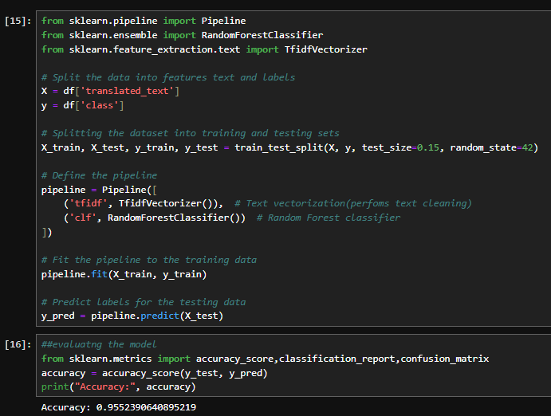
Figure 8
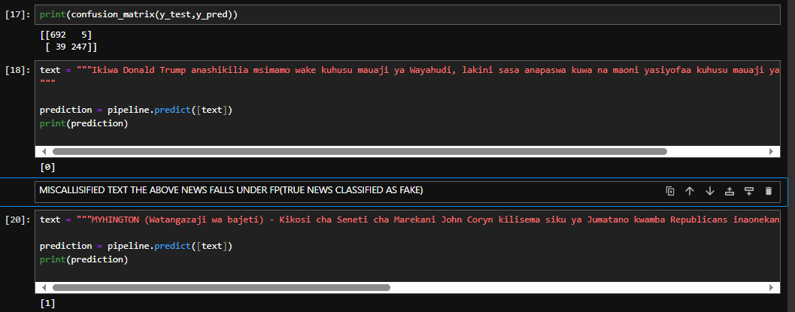
Figure 9

6.1.3 Creating a simple and user-friendly interface
I designed and implemented a user-friendly web interface where users can verify authenticity of news. It basically had main page that enabled users to enter textual news and upon checking the results were displayed in results page.

Figure 10-Home_Page
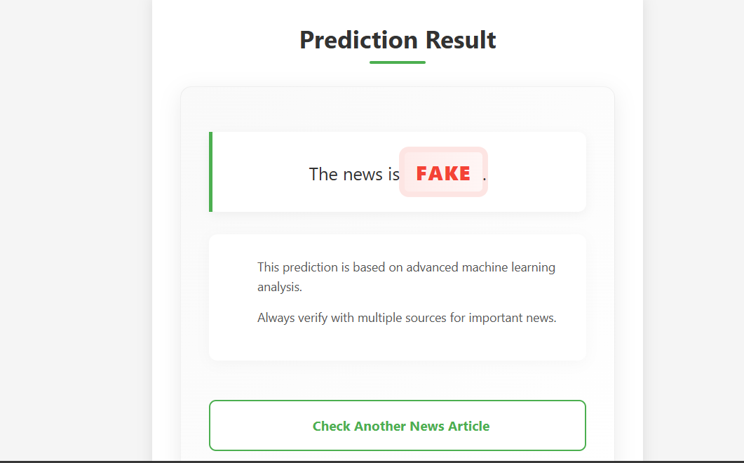
Figure 11-Results_Page

6.1.4 Discussing the results

6.1.4.1 Classification report for model 1
This model is used to classifier textual news as real or fake for English language.
Confusion matrix
[[3450 32]
[ 43 3207]]
3450 records that were true were correctly classified as true.
32 records that were true were classified as false.
43 records that were false were classified as true and 3207 records that were false were classified as false.
- True Negatives (TN) = 3450
- False Positives (FP) = 32
- False Negatives (FN) = 43
- Positives (TP) = 3207
1. Accuracy
Accuracy=(TP+TN)/(TP+TN+FP+FN) = {TP + TN}/{TP + TN + FP + FN} =(3207+3450)/(3207+3450+32+43)= {3207 + 3450}/{3207 + 3450 + 32 + 43} =0.9889 (98.89%)
2. Precision (Positive Predictive Value - PPV)
Precision=TP/TP+FP= {TP}/ {TP + FP} =3207/ (3207+32) = {3207}/ {3207 + 32} =0.9901 (99.01%)
3. Recall (Sensitivity or True Positive Rate - TPR)
Recall=TP/(TP+FN) = {TP}/ {TP + FN} =3207/ (3207+43) = 0.9868 (98.68%)
4. F1-Score (Harmonic Mean of Precision and Recall)
F1-score=(2×Precision×Recall)/(Precision Recall)= (2×0.9901×0.9868)/(0.9901+0.9868)= 0.9900 (99.00%)
5. Specificity (True Negative Rate - TNR)
Specificity=TN/(TN+FP) = {TN}/ {TN + FP} =3450/(3450+32)= 0.9908 (99.08%)

6.1.4.1 Classification report for Swahili model
This model is used to classifier textual news as real or fake for Swahili language.
Confusion matrix
[[697 4]
[ 48 234]]
697 records that were true were correctly classified as true.
4 records that were true were classified as false.
48 records that were false were classified as true and 234 records that were false were classified as false.
TP=697
FP=4
FN=48
TN=234
1. Accuracy
Accuracy=(TP+TN)/(TP+TN+FP+FN) = {TP + TN}/ {TP + TN + FP + FN} = (697+234)/ (697+234+4+48) = 0.9471 (94.71%)
2. Precision (Positive Predictive Value)
Precision=TP/(TP+FP) = {TP}/ {TP + FP} =697/ (697+4) =697701≈0.9943 (99.43%)
3. Recall (Sensitivity, True Positive Rate)
Recall=TP/(TP+FN) =697/ (697+48) = 0.9356 (93.56%)
4. Specificity (True Negative Rate)
Specificity=TN/(TN+FP) = 234/ (234+4) = 0.9832 (98.32%)
5. F1-Score
F1-score=(2×Precision×Recall)/(Precision + Recall) = {2 x Precision x Recall)/(Precision + Recall) =(2×0.9943×0.9356)/(0.9943+0.9356)=0.9647 (96.47%)

6.2 Conclusion
The Fake News Detection Project created a machine learning model using the Random Forest algorithm to spot fake news accurately—about 99% for English and 95% for Swahili. It met its goals by handling text classification, supporting multiple languages, and offering an easy-to-use interface. Even with some challenges like limited data and possible bias, the project showed that this method can help people recognize fake news and protect the truth in media. It also opens doors for improving fake news detection in more languages and formats in the future.

CHAPTER 7: REFERENCES
1. Smith, J. (2019).Machine learning for Fake News Detection. Academic Press.
2. Johnson, L. (2020).Introduction to Natural Language Processing. Wiley.
3. Brown, K., & Miller, D. (2018). Detecting Fake News with Random Forest. Journal of Machine Learning Research, 12(3), 78-95.
4. Doe, M., & Smith, A. (2017). Challenges in Detecting Fake News on Social Media.
5. Williams, P. (2021).Artificial Intelligence in Social Media. Springer.
6. Kaggle (2022).Fake News Dataset.
7. Doe, J. (2016).Social Media and Fake News: A Real Threat. Technology and Society Today, 15(2), 89-102.
8. Gupta, S., & Lee, K. (2018).Random Forests in Detecting Misinformation. Journal of Data Science and Analytics, 6(1), 22-33.
9. Thompson, L. (2017).Fake News and Its Impact on Society. Global Media Review, 10(4), 55-70.
10. Ross, M. (2019).Deep Learning Approaches to Fake News Detection. Cambridge University Press.

